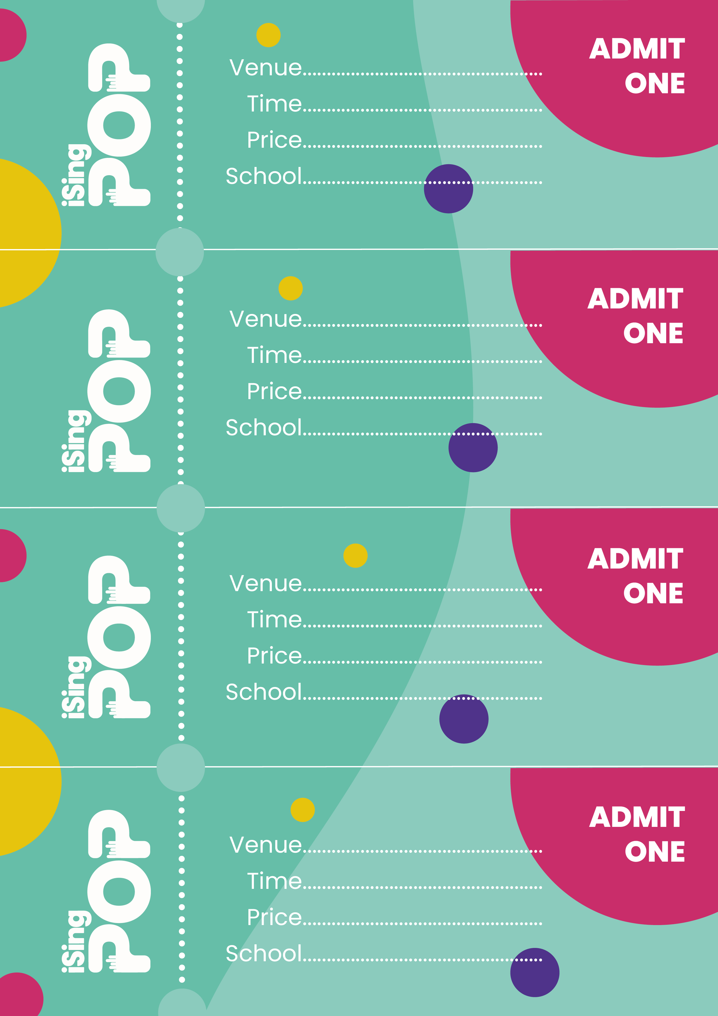

**St Examples Church**

**2pm & 6pm**

**FREE**

**St Examples CE Primary**

**y**

**St Examples Church**

**2pm & 6pm**

**FREE**

**St Examples CE Primary**

**y**

**St Examples Church**

**2pm & 6pm**

**FREE**

**St Examples CE Primary**

**y**

**St Examples Church**

**2pm & 6pm**

**FREE**

**St Examples CE Primary**

**y**